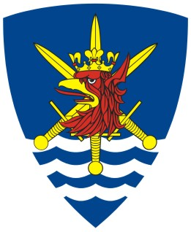

HEADQUARTERS

MULTINATIONAL CORPS NORTHEAST

Public Affairs Office

W. Łukasińskiego 33, 71-215 Szczecin, Poland
TEL: +48 (91) 44 45 955 Fax: +48 (91) 44 45 957
E-mail: contact@hqmncne.mil.pl
www.mncne.pl

Tuesday, 01 September 2009

Invitation
for the Ribbon Cutting Ceremony
of the New Multifunctional Building
at the Headquarters
Multinational Corps Northeast

On behalf of the Commander of the Multinational Corps Northeast Lieutenant General Zdzisław Goral, the Public Affairs Office would like to invite you to join us for the Ribbon Cutting Ceremony of the new multifunctional building at the Baltic Barracks, home of the Headquarters Multinational Corps Northeast (HQ MNC NE).

The event is taking place on 19 September 2009, at 1200.

Ministers of Defence of the Corps’ Framework Nations (Denmark, Germany and Poland) have been invited to take part in the ceremony.

This new building provides additional office space for the Command Group personnel as well as a multifunctional room constructed for training, exercises, seminars and conferences.

Program for media:

1140-1150 – Accreditation at the Main Gate of the Baltic Barracks, W. Łukasińskiego 33, Szczecin
1200-1300 – The Ribbon Cutting Ceremony and reception

Please fill in the attached accreditation form and return it by Tuesday September 08th, 2009, 16.00 hrs latest. Please use the e-mail address or fax number on the form. The telephone accreditation is also possible using the phone number presented above.

Should you have any questions or inquiries, please feel free to contact us.

Transport and accommodation for media representatives are at their own expense.
Yours faithfully,

Wojciech Wisniewski
Lt. Col., Polish Army
Chief Public Affairs
Public Affairs Office
Headquarters Multinational Corps Northeast
Waleriana Łukasińskiego 33, 71-215 Szczecin, Poland
Phone: 0048 91 4445 950
Fax: 0048 91 4445 957
Mobile: 0048 603 989 134
www.mncne.pl

